Two-Factor Authentication (2FA) User Manual
This manual provides instructions on how to use the two-factor authentication (2FA) system for secure access to your account.
1. Initial Login:
- Access the Login Page: Open your web browser and navigate to the login page of the application or service.
- 
- Enter Credentials: Enter your registered username and password in the respective fields.
- Submit: Click the "Login" or "Submit" button.
- Successful Login: If your username and password are correct, you will be redirected to the OTP Verification page.
- 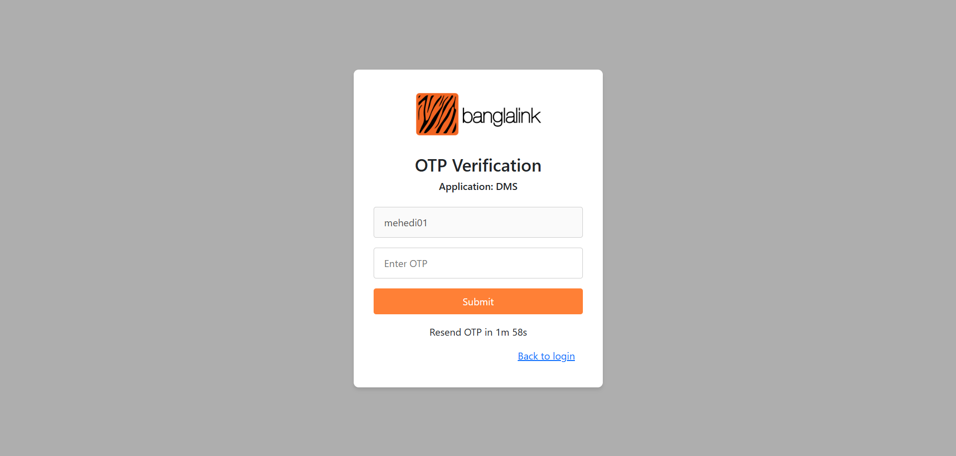
- Incorrect Login: If your username or password is incorrect, you will receive an error message. Please re-enter your credentials.
2. OTP Verification:
- OTP Delivery: Upon successful login, a One-Time Password (OTP) will be sent to both your registered email address and mobile phone number via SMS.
- OTP Validity: The OTP is valid for 2 minutes.
- OTP Input: Enter the received OTP in the designated field on the OTP Verification page.
- Timer Display: A countdown timer will be displayed, showing the remaining time for the OTP's validity.
- Submit OTP: Click the "Submit" button.
3. OTP Resend Functionality:
- Expired OTP: If the OTP expires (after 2 minutes), a "Resend OTP" button will become visible.
- 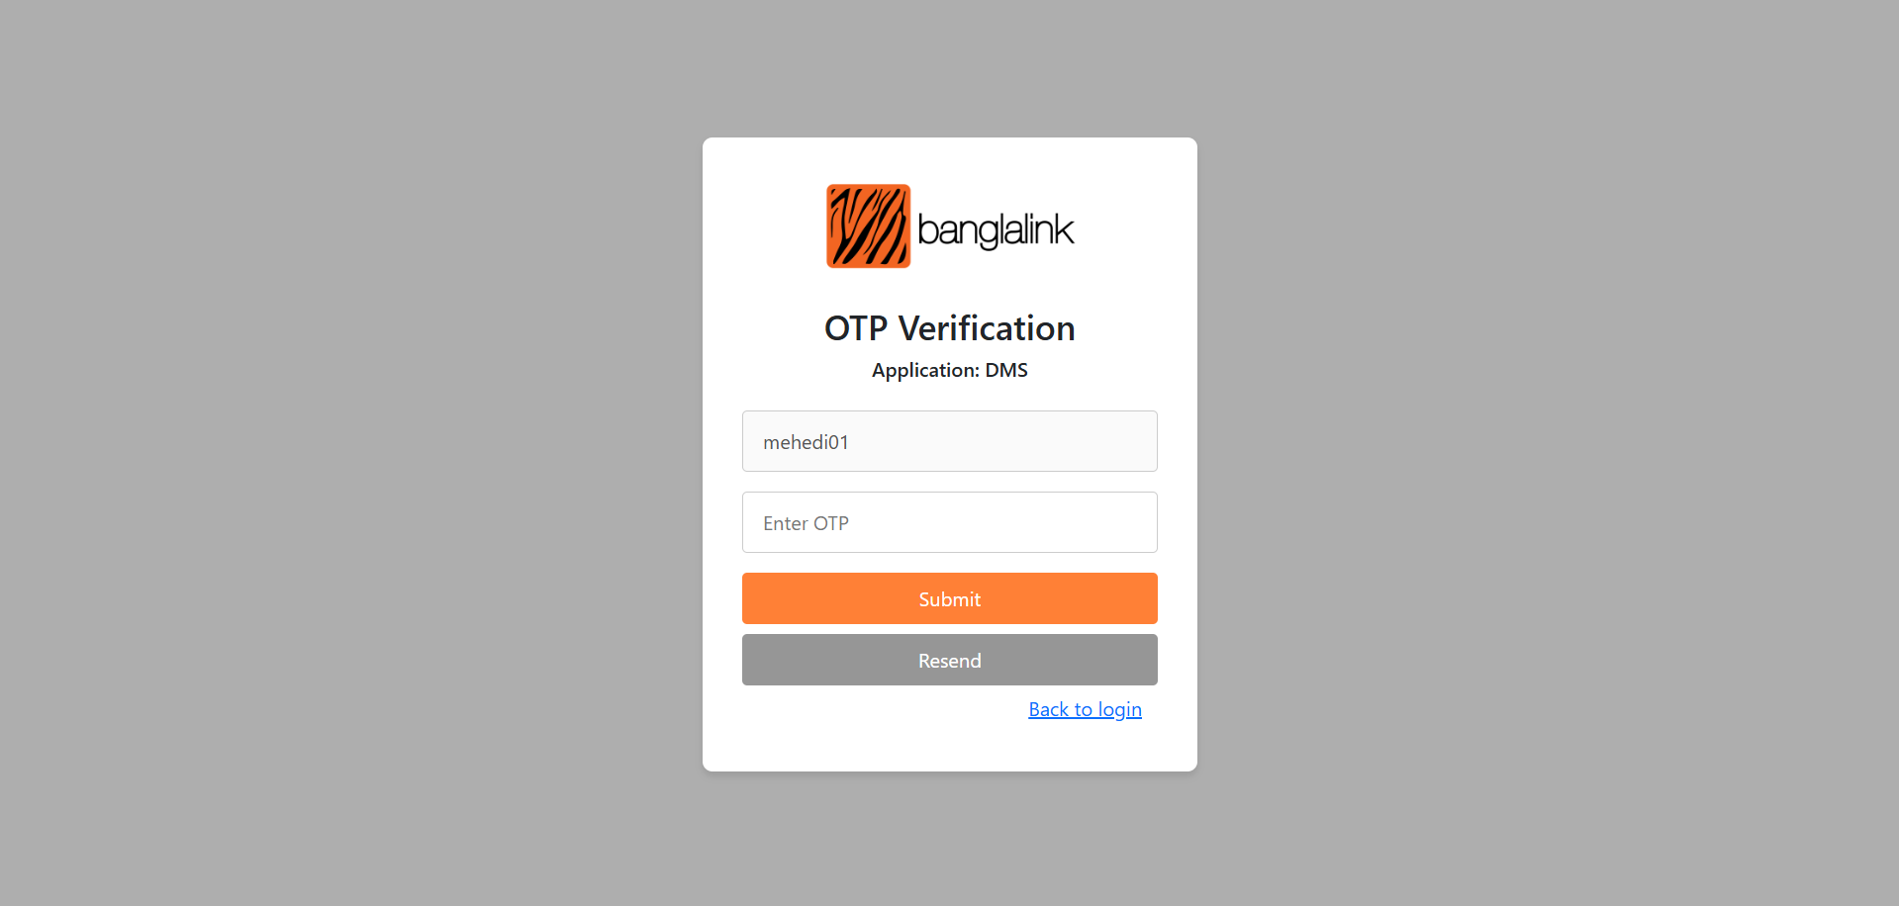
- Resend Limit: You can resend the OTP a maximum of 2 times.
- Resend Process: Clicking the "Resend OTP" button will:
  - Invalidate the previously sent OTP.
  - Send a new OTP to your registered email and mobile phone number.
  - Restart the 2-minute timer.
  - 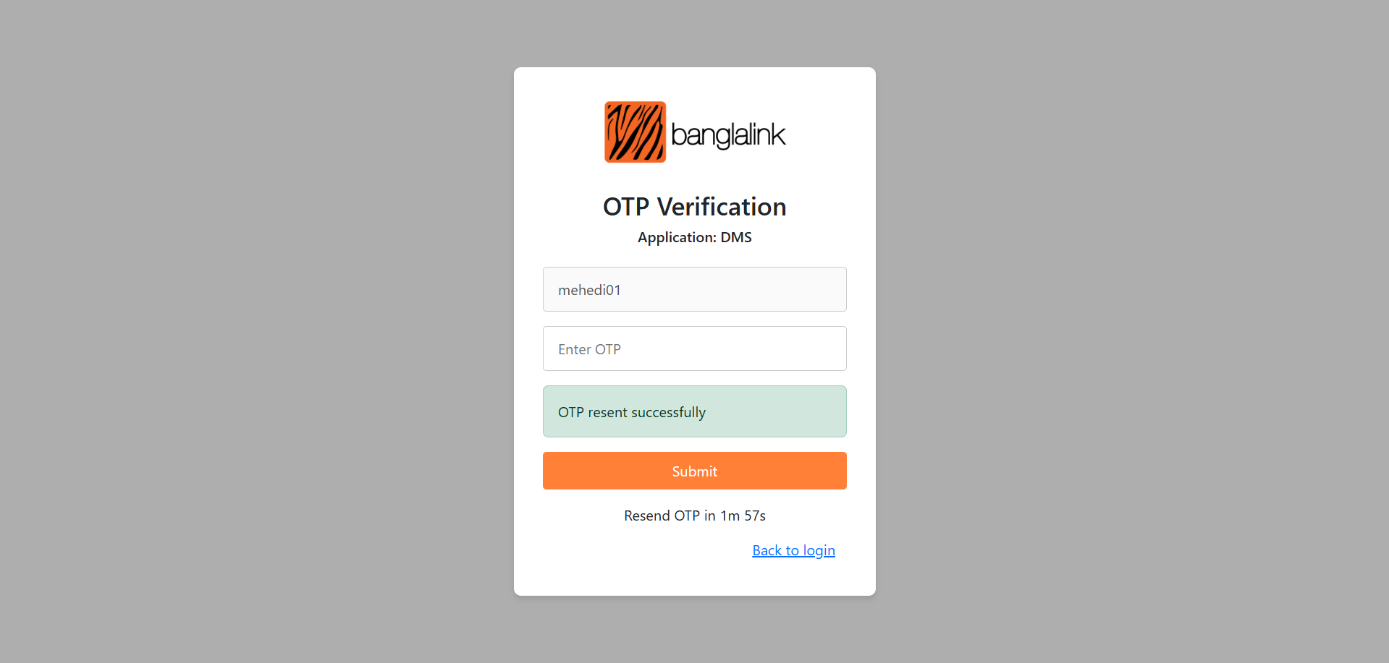
- Resend Limit Reached: If you have already resend the OTP 2 times. An error message will be shown "OTP Resend reached maximum limit". Click the "Back to login" button and initialize login process again.
- 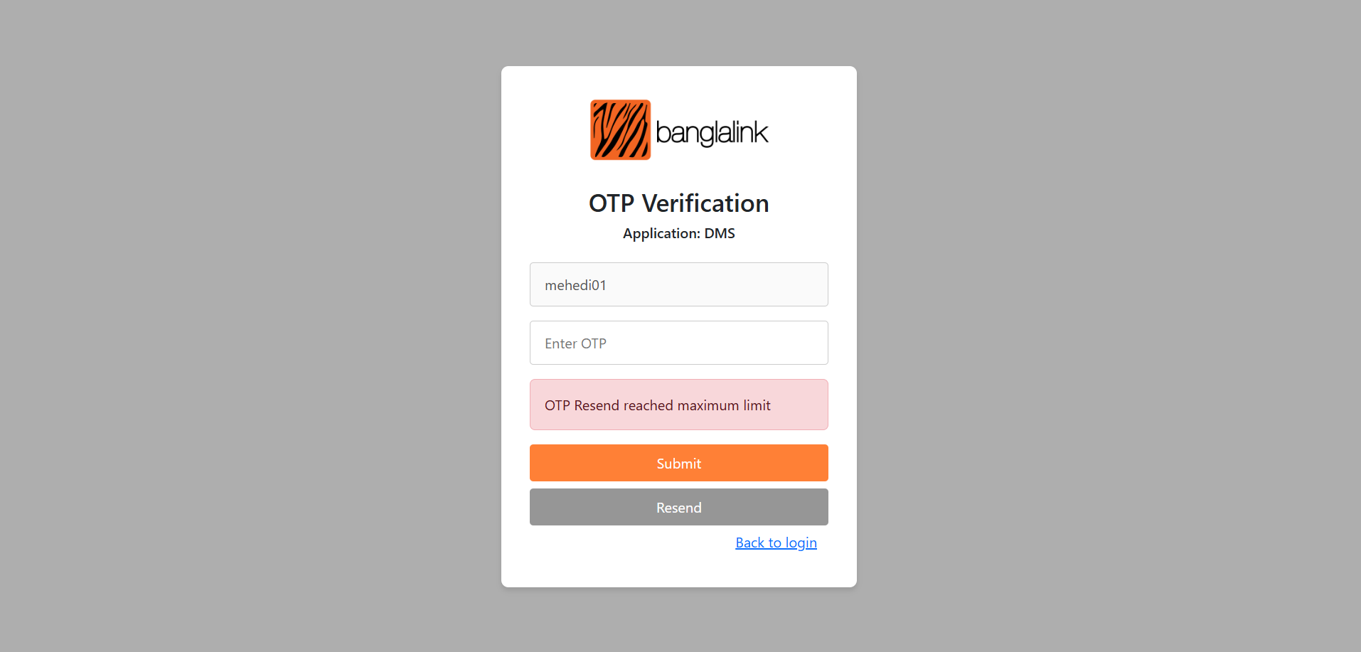
4. Wrong OTP Attempts and Account Lockout:
- Wrong OTP Limit: If you enter an incorrect OTP 3 times, your account will be locked for 30 minutes.
- Account Lockout Message: If your account is locked, the OTP verification page / login page will display an error message indicating the remaining time until your account is unlocked. For example: "You have been locked, try again after 30 minutes."
- 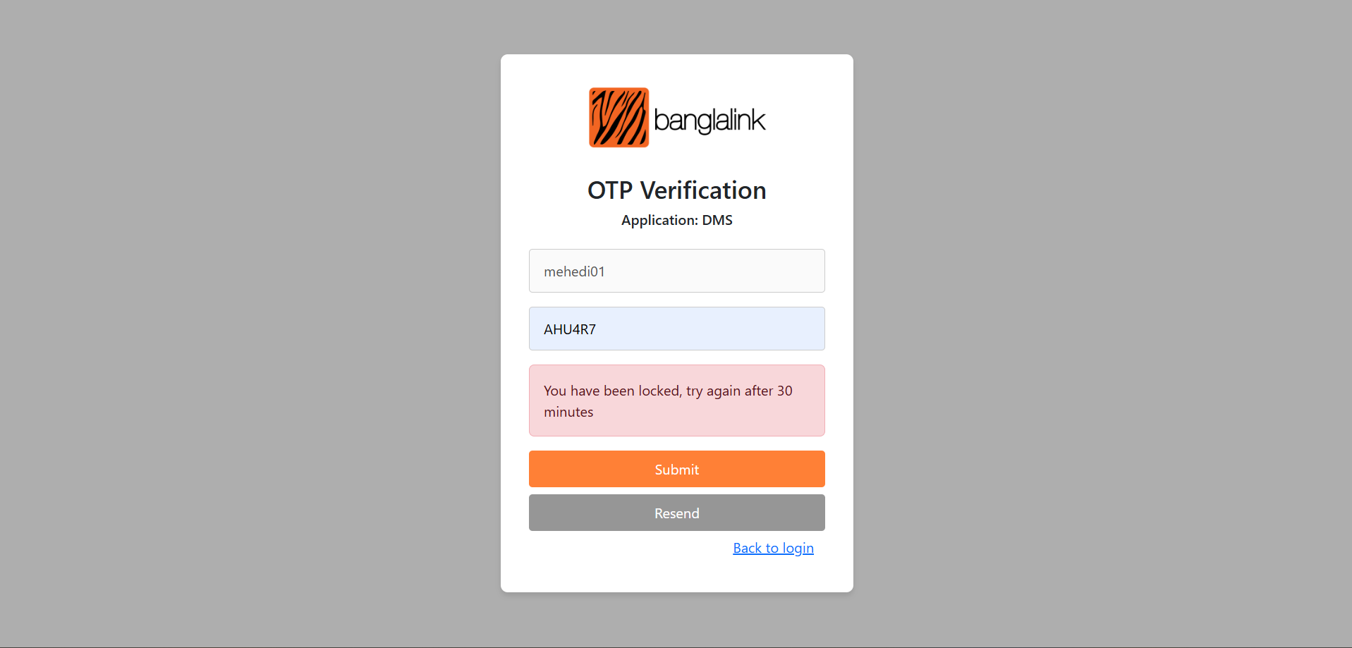
- Waiting Period: You must wait for the specified duration before attempting to log in again.
- 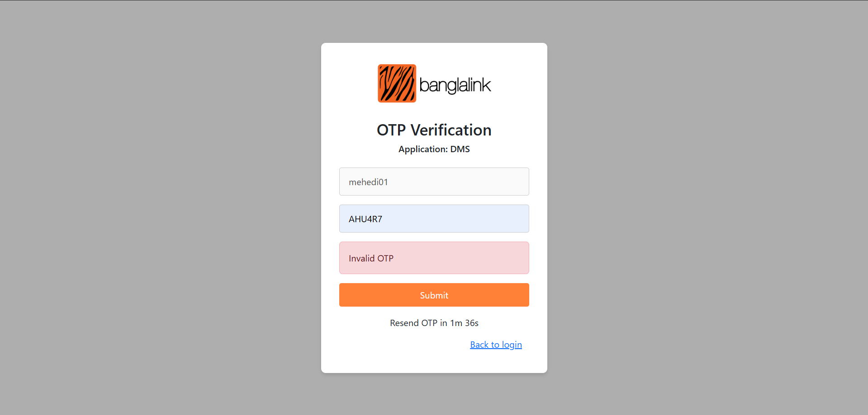
5. Back to Login:
- Back to Login Button: On the OTP Verification page, a "Back to Login" button is available.
- Return to Login: Clicking this button will redirect you back to the initial login page.
Troubleshooting:
- OTP Not Received:
  - Check your spam or junk folder in your email.
  - Ensure your mobile phone has a stable network connection.
  - Verify that your registered email and mobile phone number are correct.
  - If the issue persists, contact support.
- Incorrect OTP Error:
  - Double-check the OTP for accuracy.
  - Ensure the OTP has not expired.
  - If you have entered the incorrect OTP 3 times, wait 30 minutes and go back to login page.
- Account Lockout:
  - Wait the duration of the lockout period as displayed on the login page.
  - If you have any issues after the lockout period, contact support.
Security Best Practices:
- Keep your password secure.
- Do not share your OTP with anyone.
- Ensure your email and mobile phone are secure.
- Be aware of phishing attempts.
- Keep your software and browser up to date.

